BANKMETRIC
Conversational Analytics Platform

End-to-End Implementation Guide
On-Premises | Active Directory Integration | MS Teams / Copilot Studio Agent

Classification | CONFIDENTIAL — Internal Use Only
Version | 1.0
Environment | On-premises — No cloud dependency on data path
Authentication | Active Directory (Kerberos / LDAP)
Teams Integration | Copilot Studio agent → secured internal API
Database | Microsoft SQL Server (on-prem)
API Stack | Python FastAPI + Strawberry GraphQL
UI | Streamlit (prototype) → Copilot Studio (production)

Table of Contents
Section 1 — Architecture Overview
Section 2 — Prerequisites & Server Setup
Section 3 — Project Structure & Dependencies
Section 4 — Database Layer — SQL Server
Section 5 — Active Directory Integration
Section 6 — Permission Registry
Section 7 — FastAPI Application & Auth Middleware
Section 8 — GraphQL API & Row-Level Security
Section 9 — NL Parser
Section 10 — Nginx Reverse Proxy Configuration
Section 11 — Streamlit Chat UI
Section 12 — Copilot Studio Agent Setup
Section 13 — Teams Deployment
Section 14 — Security Hardening Checklist
Section 15 — Testing & Validation
Section 16 — Operational Runbook
Section 17 — Extending the Platform

SECTION 1 Architecture Overview
This platform is fully on-premises. No data leaves your bank network. The only outbound connection is the identity token passed from Microsoft Teams to Copilot Studio — which already exists as part of your M365 tenant. Your SQL Server, your metrics definitions, and all query results stay inside your firewall.

1.1 Full Stack Diagram
Read top-to-bottom: user types in Teams → identity flows through → SQL Server returns scoped results → response rendered in Teams.

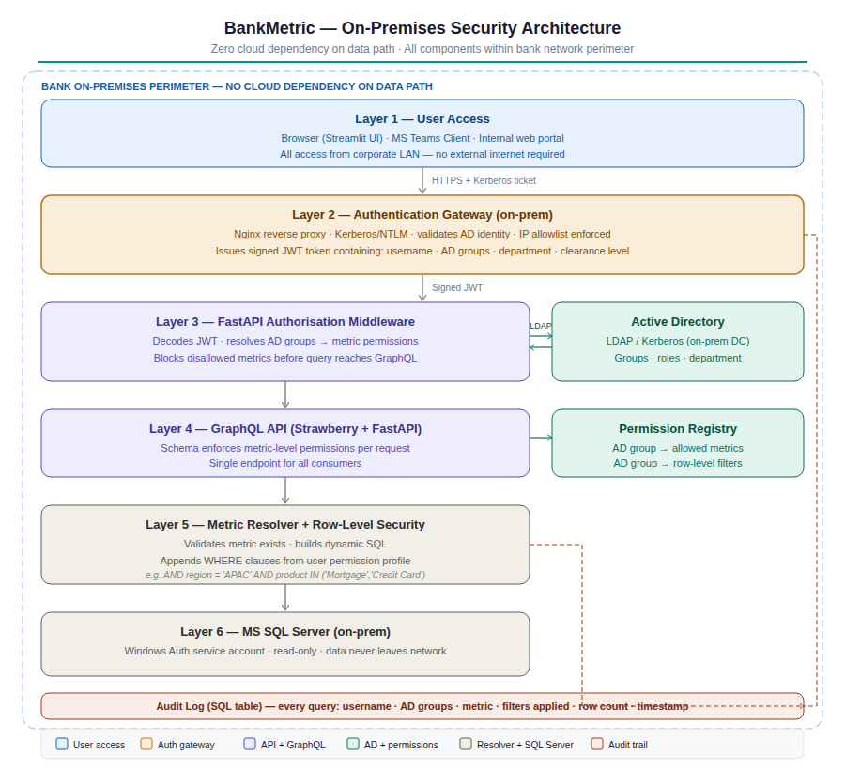
Layer | Component
User interface | MS Teams chat — Copilot Studio agent
NL understanding | Copilot Studio LLM slot-filling (built-in, no extra API)
Identity | M365 AAD token → UPN forwarded in HTTP header
Network edge | Nginx reverse proxy — validates M365 tenant signature
Authentication | FastAPI middleware — verifies UPN, queries AD via LDAP
Authorisation | Permission registry — maps AD groups to allowed metrics + row filters
API | FastAPI + Strawberry GraphQL — single endpoint, schema-enforced access
Query engine | Metric resolver — builds dynamic SQL + injects WHERE clauses
Data | MS SQL Server — Windows Auth service account, read-only
Audit | SQL table — every query logged with user, groups, filters applied

1.2 Identity Flow Summary
When a user sends a message in Teams:
- Teams authenticates the user via their corporate AD/AAD credentials (already done — they are logged in).
- Copilot Studio receives the verified AAD token containing UPN (e.g. jsmith@bank.com), AAD object ID, and display name.
- Copilot Studio's LLM extracts the metric intent from the message (no regex needed).
- Copilot Studio calls your API: POST /query with the structured query and x-user-upn header.
- Nginx validates the M365 tenant signature on the request. Forged requests are rejected here.
- FastAPI middleware queries your on-prem AD via LDAP to get jsmith's security groups.
- Permission registry maps those groups to: which metrics they can see, which regions, which row filters.
- GraphQL resolver builds SQL with injected WHERE clauses. User only sees data they are permitted to see.
- Result returned to Copilot Studio, rendered as Adaptive Card in Teams.
- Every query written to audit log: who, what, when, what filters were applied, how many rows returned.

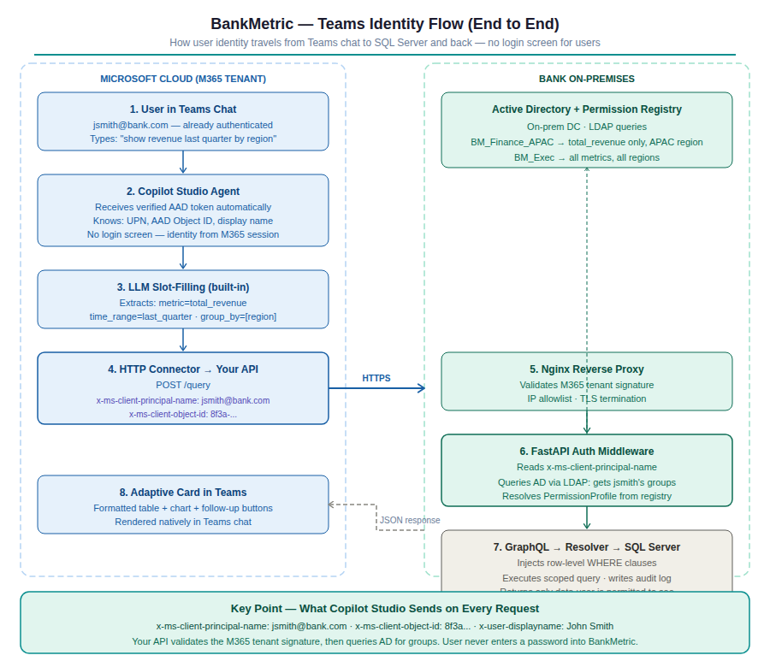

1.3 Security Layers
Layer | Mechanism | What it blocks
Layer 1 — Network | Nginx on DMZ, internal-only binding | External internet access to API
Layer 2 — Authentication | M365 tenant signature validation | Spoofed requests from outside tenant
Layer 3 — Identity | LDAP query to on-prem AD | Use of stale or incorrect group claims
Layer 4 — Authorisation | Permission registry + FastAPI middleware | Access to metrics user is not permitted to see
Layer 5 — Data | Row-level SQL WHERE injection | Seeing data outside permitted scope even if metric is allowed
Layer 6 — Audit | Immutable SQL audit log | Undetected data access, regulatory non-compliance

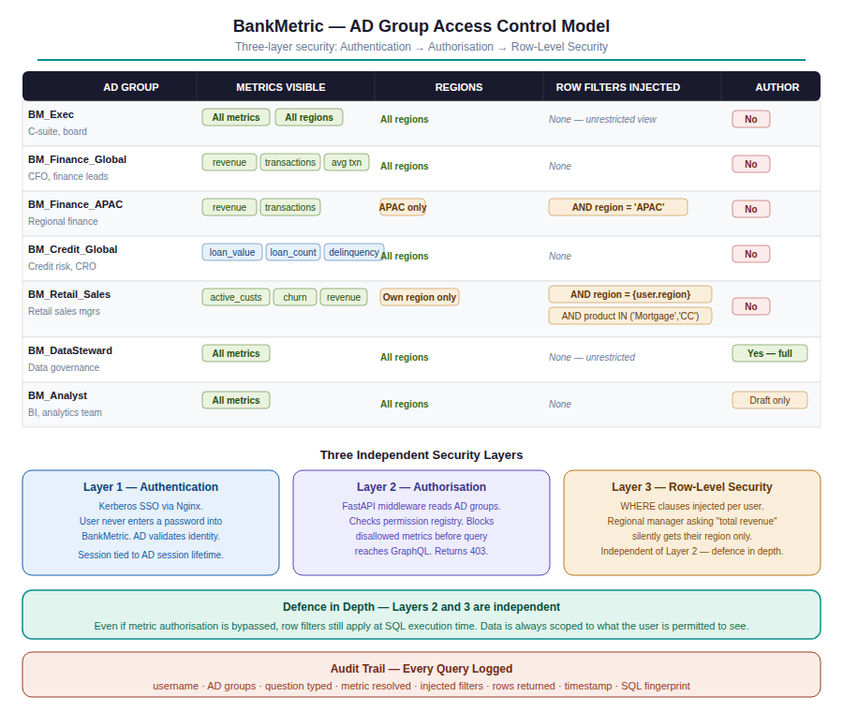

SECTION 2 Prerequisites & Server Setup

2.1 Infrastructure Required
Component | Specification | Purpose | Notes
Application server | Windows Server 2019+ or RHEL 8+ | Hosts FastAPI, Nginx | Must be domain-joined
Python | 3.11 or 3.12 | API runtime | Install system-wide or venv
MS SQL Server | 2017 or later | Data + metric registry + audit log | Existing instance fine
ODBC Driver | Microsoft ODBC Driver 17 or 18 | Python-to-SQL connection | Install on app server
Active Directory | Windows Server AD DS | User auth + groups | Existing bank AD
Nginx | 1.24+ | Reverse proxy + TLS termination | Or IIS with ARR
SSL Certificate | Internal CA or commercial | HTTPS for API | Must be trusted by M365
M365 tenant | E3 or E5 + Copilot Studio licence | Teams agent hosting | Cloud-side only
Network rule | Inbound HTTPS 443 from M365 IPs | Teams agent to call API | See Microsoft IP ranges

2.2 Network Requirements
Your firewall must allow inbound HTTPS (port 443) from Microsoft's published IP ranges for Copilot Studio outbound connectors. See: https://learn.microsoft.com/en-us/connectors/common/outbound-ip-addresses

Required network rules:
- Inbound 443: Microsoft Copilot Studio connector IPs → App server (Nginx)
- Outbound 389/636 (LDAP/LDAPS): App server → Domain controller
- Outbound 1433: App server → SQL Server
- No internet access from app server required

2.3 Domain Join Verification
Verify the application server is domain-joined before proceeding:
# Windows
systeminfo | findstr /B /C:"Domain"

# Linux (RHEL)
realm list
# Expected output: domain-name: bank.internal

SECTION 3 Project Structure & Dependencies

3.1 Folder Structure
Create this exact structure on your application server:
bankmetric/
├── main.py # FastAPI entry point
├── requirements.txt
├── .env # Secrets (never commit to git)
├── nginx/
│ └── bankmetric.conf # Nginx site config
├── db/
│ ├── __init__.py
│ ├── database.py # SQL Server connection
│ └── seed.py # Initial data + schema
├── auth/
│ ├── __init__.py
│ ├── middleware.py # AD auth middleware
│ ├── ad_client.py # LDAP/AD queries
│ └── permissions.py # Permission registry resolver
├── api/
│ ├── __init__.py
│ └── graphql_api.py # Strawberry schema + resolvers
├── parser/
│ ├── __init__.py
│ └── nl_parser.py # Rule-based NL parser (Streamlit)
└── streamlit_app/
└── app.py # Streamlit UI (pilot/testing)

3.2 Install Dependencies
On your application server (run as administrator / sudo):
# Create virtual environment
python -m venv venv

# Activate
# Windows:
venv\Scripts\activate
# Linux:
source venv/bin/activate

# Install all packages
pip install -r requirements.txt

3.3 requirements.txt — Full Contents
Copy this exactly into requirements.txt in your project root.
# API framework
fastapi==0.115.0
uvicorn[standard]==0.30.0

# GraphQL
strawberry-graphql[fastapi]==0.243.0

# Database
pyodbc==5.1.0

# Active Directory / LDAP
ldap3==2.9.1

# JWT token handling
python-jose[cryptography]==3.3.0
cryptography==42.0.5

# HTTP + validation
pydantic==2.9.0
requests==2.32.3
python-dotenv==1.0.1

# Streamlit UI (pilot only)
streamlit==1.38.0
pandas==2.2.3

3.4 .env File — Secrets
NEVER commit .env to git. Add it to .gitignore immediately.
# SQL Server
SQL_SERVER=YOURSQLSERVER\INSTANCE
SQL_DATABASE=bankmetric
SQL_DRIVER={ODBC Driver 17 for SQL Server}

# Active Directory
AD_SERVER=ldaps://dc01.bank.internal
AD_DOMAIN=bank.internal
AD_SERVICE_USER=svc_bankmetric@bank.internal
AD_SERVICE_PASSWORD=<service-account-password>
AD_BASE_DN=DC=bank,DC=internal
AD_GROUP_BASE_DN=OU=BankMetric,DC=bank,DC=internal

# M365 Tenant validation
M365_TENANT_ID=<your-azure-tenant-id>
ALLOWED_CONNECTOR_IPS=40.74.0.0/18,13.69.0.0/17

# App
APP_SECRET_KEY=<generate-random-32-char-string>
APP_ENVIRONMENT=production
LOG_LEVEL=INFO

SECTION 4 Database Layer — SQL Server

4.1 Create the BankMetric Database
Run this SQL on your SQL Server instance using SQL Server Management Studio (SSMS) or sqlcmd:
-- Run as sysadmin
CREATE DATABASE bankmetric;
GO

USE bankmetric;
GO

-- Service account login (Windows Auth)
-- Replace BANK\svc_bankmetric with your domain\account
CREATE LOGIN [BANK\svc_bankmetric] FROM WINDOWS;
CREATE USER [BANK\svc_bankmetric] FOR LOGIN [BANK\svc_bankmetric];

-- Read-only on data tables
EXEC sp_addrolemember 'db_datareader', 'BANK\svc_bankmetric';

-- Read/write on audit and registry tables only
GRANT INSERT ON audit_log TO [BANK\svc_bankmetric];
GRANT SELECT, INSERT, UPDATE ON metric_registry TO [BANK\svc_bankmetric];
GRANT SELECT, INSERT, UPDATE ON permission_registry TO [BANK\svc_bankmetric];

4.2 Schema — All Tables

4.2.1 Core Fact Tables
USE bankmetric;

CREATE TABLE customers (
id INT IDENTITY(1,1) PRIMARY KEY,
name NVARCHAR(100) NOT NULL,
joined_date DATE NOT NULL,
region NVARCHAR(50) NOT NULL,
product NVARCHAR(50) NOT NULL,
status NVARCHAR(20) NOT NULL, -- active|inactive|churned
channel NVARCHAR(20) NOT NULL
);

CREATE TABLE transactions (
id INT IDENTITY(1,1) PRIMARY KEY,
transaction_date DATE NOT NULL,
amount DECIMAL(18,2) NOT NULL,
region NVARCHAR(50) NOT NULL,
product NVARCHAR(50) NOT NULL,
channel NVARCHAR(20) NOT NULL,
status NVARCHAR(20) NOT NULL, -- completed|pending|failed
customer_id INT REFERENCES customers(id)
);

CREATE TABLE loans (
id INT IDENTITY(1,1) PRIMARY KEY,
origination_date DATE NOT NULL,
amount DECIMAL(18,2) NOT NULL,
region NVARCHAR(50) NOT NULL,
product NVARCHAR(50) NOT NULL,
status NVARCHAR(20) NOT NULL -- current|delinquent|defaulted|paid_off
);

-- Indexes for performance
CREATE INDEX ix_txn_date_region ON transactions(transaction_date, region);
CREATE INDEX ix_txn_date_product ON transactions(transaction_date, product);
CREATE INDEX ix_loan_date_region ON loans(origination_date, region);
CREATE INDEX ix_cust_region ON customers(region, status);

4.2.2 Metric Registry
CREATE TABLE metric_registry (
id INT IDENTITY(1,1) PRIMARY KEY,
metric_name NVARCHAR(100) UNIQUE NOT NULL,
display_name NVARCHAR(150) NOT NULL,
description NVARCHAR(500),
formula NVARCHAR(500) NOT NULL,
source_table NVARCHAR(100) NOT NULL,
allowed_dims NVARCHAR(200) NOT NULL, -- comma-separated
owner NVARCHAR(100),
status NVARCHAR(20) DEFAULT 'published', -- draft|published|deprecated
created_by NVARCHAR(100),
created_at DATETIME DEFAULT GETDATE(),
updated_at DATETIME DEFAULT GETDATE()
);

4.2.3 Permission Registry
CREATE TABLE permission_registry (
id INT IDENTITY(1,1) PRIMARY KEY,
ad_group NVARCHAR(100) NOT NULL,
metric_name NVARCHAR(100), -- NULL = all metrics
allowed_regions NVARCHAR(200), -- NULL = all regions; comma-sep list
row_filter_col NVARCHAR(100), -- e.g. 'region'
row_filter_val NVARCHAR(200), -- e.g. 'APAC'
can_author BIT DEFAULT 0,
created_at DATETIME DEFAULT GETDATE()
);

-- Example rows
INSERT INTO permission_registry (ad_group, metric_name, allowed_regions, can_author)
VALUES
('BM_Exec', NULL, NULL, 0),
('BM_Finance_Global', 'total_revenue', NULL, 0),
('BM_Finance_Global', 'transaction_count', NULL, 0),
('BM_Finance_Global', 'average_transaction', NULL, 0),
('BM_Finance_APAC', 'total_revenue', 'APAC', 0),
('BM_Credit_Global', 'total_loan_value', NULL, 0),
('BM_Credit_Global', 'delinquency_rate', NULL, 0),
('BM_Credit_Global', 'loan_count', NULL, 0),
('BM_Retail_Sales', 'active_customers', NULL, 0),
('BM_Retail_Sales', 'churn_rate', NULL, 0),
('BM_DataSteward', NULL, NULL, 1),
('BM_Analyst', NULL, NULL, 0);

4.2.4 Audit Log
CREATE TABLE audit_log (
id BIGINT IDENTITY(1,1) PRIMARY KEY,
logged_at DATETIME DEFAULT GETDATE(),
username NVARCHAR(100) NOT NULL,
ad_groups NVARCHAR(500),
question_raw NVARCHAR(1000),
metric_resolved NVARCHAR(100),
time_range NVARCHAR(50),
group_by NVARCHAR(200),
filters_explicit NVARCHAR(500),
filters_injected NVARCHAR(500),
date_from DATE,
date_to DATE,
row_count INT,
sql_fingerprint NVARCHAR(64), -- SHA-256 of generated SQL
response_ms INT,
error NVARCHAR(500)
);

-- Retention index (query by user or date range for audits)
CREATE INDEX ix_audit_user_date ON audit_log(username, logged_at);
CREATE INDEX ix_audit_date ON audit_log(logged_at);

4.3 db/database.py — Full Code
import pyodbc
import os
from dotenv import load_dotenv

load_dotenv()

_conn = None

def get_connection():
global _conn
if _conn is None or _conn.closed:
conn_str = (
f"DRIVER={os.getenv('SQL_DRIVER')};"
f"SERVER={os.getenv('SQL_SERVER')};"
f"DATABASE={os.getenv('SQL_DATABASE')};"
"Trusted_Connection=yes;"
"TrustServerCertificate=yes;"
)
_conn = pyodbc.connect(conn_str, autocommit=False)
return _conn

def execute_query(sql: str, params: list = []) -> list[dict]:
conn = get_connection()
cursor = conn.execute(sql, params)
cols = [d[0] for d in cursor.description]
return [dict(zip(cols, row)) for row in cursor.fetchall()]

def write_audit(record: dict):
conn = get_connection()
conn.execute(
'''INSERT INTO audit_log
(username, ad_groups, question_raw, metric_resolved,
time_range, group_by, filters_explicit, filters_injected,
date_from, date_to, row_count, sql_fingerprint, response_ms, error)
VALUES (?,?,?,?,?,?,?,?,?,?,?,?,?,?)''',
[record.get(k) for k in [
'username','ad_groups','question_raw','metric_resolved',
'time_range','group_by','filters_explicit','filters_injected',
'date_from','date_to','row_count','sql_fingerprint','response_ms','error'
]]
)
conn.commit()

SECTION 5 Active Directory Integration

5.1 Create AD Groups
In Active Directory Users and Computers (or via PowerShell), create these security groups in an OU named BankMetric:
# PowerShell — run on domain controller as Domain Admin

# Create OU
New-ADOrganizationalUnit -Name 'BankMetric' -Path 'DC=bank,DC=internal'

# Create groups
$groups = @(
'BM_Exec',
'BM_Finance_Global',
'BM_Finance_APAC',
'BM_Finance_Europe',
'BM_Finance_NorthAmerica',
'BM_Credit_Global',
'BM_Retail_Sales',
'BM_DataSteward',
'BM_Analyst'
)

$groups | ForEach-Object {
New-ADGroup -Name $_ -SamAccountName $_ \
-GroupScope Global -GroupCategory Security \
-Path 'OU=BankMetric,DC=bank,DC=internal' \
-Description 'BankMetric access group'
}

# Create service account for LDAP queries
New-ADUser -Name 'svc_bankmetric' \
-UserPrincipalName 'svc_bankmetric@bank.internal' \
-SamAccountName 'svc_bankmetric' \
-AccountPassword (ConvertTo-SecureString 'P@ssw0rd!' -AsPlainText -Force) \
-Enabled $true \
-PasswordNeverExpires $true \
-Path 'OU=ServiceAccounts,DC=bank,DC=internal'

# Grant service account read-only access to AD
# (Default Domain Users read is sufficient for LDAP queries)

5.2 auth/ad_client.py — Full Code
This module queries AD to get a user's groups given their UPN. It caches results for 5 minutes to avoid LDAP hammering on every API call.
import os
import time
from ldap3 import Server, Connection, ALL, NTLM
from dotenv import load_dotenv
import logging

load_dotenv()
logger = logging.getLogger(__name__)

# Simple in-memory cache: {upn: (groups, timestamp)}
_cache: dict = {}
CACHE_TTL = 300 # 5 minutes

def get_user_groups(upn: str) -> list[str]:
'''
Given a UPN like jsmith@bank.internal,
return list of BankMetric AD group names the user belongs to.
Returns [] if user not found or LDAP error.
'''
# Check cache
if upn in _cache:
groups, ts = _cache[upn]
if time.time() - ts < CACHE_TTL:
return groups

try:
server = Server(os.getenv('AD_SERVER'), get_info=ALL)
conn = Connection(
server,
user=os.getenv('AD_SERVICE_USER'),
password=os.getenv('AD_SERVICE_PASSWORD'),
authentication=NTLM,
auto_bind=True
)

# Search for user's group memberships
# Only return groups in the BankMetric OU
base = os.getenv('AD_BASE_DN')
conn.search(
search_base=base,
search_filter=f'(userPrincipalName={upn})',
attributes=['memberOf', 'sAMAccountName', 'department', 'title']
)

if not conn.entries:
logger.warning(f'User not found in AD: {upn}')
return []

entry = conn.entries[0]
all_groups = entry.memberOf.values if entry.memberOf else []

# Extract just the CN (group name) from DN
# e.g. CN=BM_Finance_APAC,OU=BankMetric,DC=bank,DC=internal -> BM_Finance_APAC
bm_groups = []
for dn in all_groups:
parts = dict(p.split('=', 1) for p in dn.split(',') if '=' in p)
cn = parts.get('CN', '')
if cn.startswith('BM_'):
bm_groups.append(cn)

# Also capture department for dynamic row filters
dept = str(entry.department) if entry.department else None

conn.unbind()

# Cache result
_cache[upn] = (bm_groups, time.time())
logger.info(f'AD groups for {upn}: {bm_groups}')
return bm_groups

except Exception as e:
logger.error(f'LDAP error for {upn}: {e}')
return []

def clear_cache(upn: str = None):
'''Clear cache for a specific user or all users.'''
if upn:
_cache.pop(upn, None)
else:
_cache.clear()

SECTION 6 Permission Registry

6.1 auth/permissions.py — Full Code
This module reads the permission_registry table and resolves what a user (by their AD groups) is allowed to query. It returns a PermissionProfile used by the resolver to scope every query.
from dataclasses import dataclass, field
from db.database import execute_query
import logging

logger = logging.getLogger(__name__)

@dataclass
class PermissionProfile:
username: str
ad_groups: list[str]
allowed_metrics: list[str] | None # None = all metrics
allowed_regions: list[str] | None # None = all regions
row_filters: list[dict] # [{col, val}] injected into WHERE
can_author: bool = False

def resolve_permissions(upn: str, ad_groups: list[str]) -> PermissionProfile:
'''
Given a UPN and their AD groups, query the permission_registry
and return a PermissionProfile describing what they can access.
'''
if not ad_groups:
# No BankMetric groups = no access
return PermissionProfile(
username=upn, ad_groups=[],
allowed_metrics=[], allowed_regions=[],
row_filters=[], can_author=False
)

# Build SQL placeholders
placeholders = ','.join(['?' for _ in ad_groups])
rows = execute_query(
f'''SELECT ad_group, metric_name, allowed_regions,
row_filter_col, row_filter_val, can_author
FROM permission_registry
WHERE ad_group IN ({placeholders})''',
ad_groups
)

if not rows:
return PermissionProfile(
username=upn, ad_groups=ad_groups,
allowed_metrics=[], allowed_regions=[],
row_filters=[], can_author=False
)

# Union all permissions across groups (most permissive wins)
metrics_set = set()
regions_set = set()
row_filters = []
can_author = False
has_all_metrics = False
has_all_regions = False

for row in rows:
if row['metric_name'] is None:
has_all_metrics = True # NULL = unrestricted
else:
metrics_set.add(row['metric_name'])

if row['allowed_regions'] is None:
has_all_regions = True
else:
for r in row['allowed_regions'].split(','):
regions_set.add(r.strip())

if row['row_filter_col'] and row['row_filter_val']:
row_filters.append({
'col': row['row_filter_col'],
'val': row['row_filter_val']
})

if row['can_author']:
can_author = True

return PermissionProfile(
username=upn,
ad_groups=ad_groups,
allowed_metrics=None if has_all_metrics else list(metrics_set),
allowed_regions=None if has_all_regions else list(regions_set),
row_filters=row_filters,
can_author=can_author
)

def is_metric_allowed(metric: str, profile: PermissionProfile) -> bool:
if profile.allowed_metrics is None:
return True
return metric in profile.allowed_metrics

SECTION 7 FastAPI Application & Auth Middleware

7.1 auth/middleware.py — Full Code
Every request passes through this middleware. It reads the x-user-upn header (set by Nginx after validating the M365 signature), queries AD for groups, resolves permissions, and attaches the PermissionProfile to the request state.
from fastapi import Request, HTTPException
from starlette.middleware.base import BaseHTTPMiddleware
from auth.ad_client import get_user_groups
from auth.permissions import resolve_permissions
import logging
import os

logger = logging.getLogger(__name__)

# Paths that skip auth (health check only)
PUBLIC_PATHS = {'/health', '/docs', '/openapi.json', '/redoc'}

class ADAuthMiddleware(BaseHTTPMiddleware):

async def dispatch(self, request: Request, call_next):
if request.url.path in PUBLIC_PATHS:
return await call_next(request)

# Get UPN from header (set by Nginx after tenant validation)
upn = request.headers.get('x-user-upn', '').lower().strip()

if not upn:
# Fallback: check for direct bearer token (Streamlit pilot mode)
auth = request.headers.get('Authorization', '')
if auth.startswith('Bearer pilot:'):
upn = auth.split('pilot:')[1].strip()
else:
raise HTTPException(status_code=401,
detail='Missing user identity. x-user-upn header required.')

# Validate UPN format
domain = os.getenv('AD_DOMAIN', 'bank.internal')
if '@' not in upn:
upn = f'{upn}@{domain}'

# Fetch AD groups
groups = get_user_groups(upn)
logger.info(f'Request from {upn} | groups: {groups} | path: {request.url.path}')

# Resolve permission profile
profile = resolve_permissions(upn, groups)

if not profile.ad_groups and not profile.allowed_metrics == []:
raise HTTPException(status_code=403,
detail=f'User {upn} has no BankMetric permissions. '
f'Contact your data governance team.')

# Attach to request state for use in endpoints
request.state.user_upn = upn
request.state.permission_profile = profile

response = await call_next(request)
return response

7.2 main.py — Full Code
import sys, os
sys.path.insert(0, os.path.dirname(os.path.abspath(__file__)))

from fastapi import FastAPI, Request
from fastapi.middleware.cors import CORSMiddleware
from fastapi.responses import JSONResponse
from pydantic import BaseModel
from typing import Optional
import hashlib, time, json
from dotenv import load_dotenv

load_dotenv()

from db.database import write_audit
from auth.middleware import ADAuthMiddleware
from parser.nl_parser import parse
from api.graphql_api import graphql_router, build_and_execute

app = FastAPI(title='BankMetric API', version='1.0.0')

# Attach AD auth middleware
app.add_middleware(ADAuthMiddleware)
app.add_middleware(
CORSMiddleware,
allow_origins=['https://teams.microsoft.com',
'https://*.botframework.com'],
allow_methods=['POST', 'GET'],
allow_headers=['*'],
)

# Mount GraphQL
app.include_router(graphql_router, prefix='/graphql')

class QueryRequest(BaseModel):
question: str
conversation_context: list[dict] = []

@app.post('/query')
async def query(req: QueryRequest, request: Request):
'''Main endpoint called by Copilot Studio and Streamlit.'''
start = time.time()
profile = request.state.permission_profile
upn = request.state.user_upn

# Parse NL
query_obj = parse(req.question, req.conversation_context)

if query_obj.error:
_log_audit(upn, profile, req.question, None, None, 0,
int((time.time()-start)*1000), query_obj.error)
return JSONResponse({'success': False, 'error': query_obj.error})

# Authorisation check — metric level
from auth.permissions import is_metric_allowed
if not is_metric_allowed(query_obj.metric, profile):
msg = f'You do not have permission to access metric: {query_obj.metric}'
_log_audit(upn, profile, req.question, query_obj.metric, None, 0,
int((time.time()-start)*1000), msg)
return JSONResponse({'success': False, 'error': msg}, status_code=403)

# Inject row-level filters from permission profile
for f in profile.row_filters:
if f['col'] not in query_obj.filters:
query_obj.filters[f['col']] = f['val']

# Execute via GraphQL resolver
response = build_and_execute(query_obj)
elapsed = int((time.time()-start)*1000)

# Audit log
r = response.response
sql_fp = hashlib.sha256((r.sql_generated if r else '').encode()).hexdigest()[:16]
_log_audit(upn, profile, req.question, query_obj.metric,
r.sql_generated if r else None,
r.row_count if r else 0, elapsed,
response.error.message if response.error else None,
query_obj, sql_fp)

if not response.success:
return JSONResponse({'success': False,
'error': response.error.message})

return JSONResponse({
'success': True,
'metric': r.metric_name,
'display_name': r.display_name,
'time_range': r.time_range,
'date_from': r.date_from,
'date_to': r.date_to,
'group_by': r.group_by,
'results': [{'dimension': x.dimension, 'value': x.value,
'formatted_value': x.formatted_value}
for x in r.results],
'total': r.total,
'formatted_total': r.formatted_total,
'row_count': r.row_count,
})

def _log_audit(upn, profile, question, metric, sql,
rows, ms, error=None, qobj=None, sql_fp=None):
try:
write_audit({
'username': upn,
'ad_groups': ','.join(profile.ad_groups) if profile else '',
'question_raw': question[:1000],
'metric_resolved': metric,
'time_range': qobj.time_range if qobj else None,
'group_by': ','.join(qobj.group_by) if qobj else None,
'filters_explicit': json.dumps(qobj.filters) if qobj else None,
'filters_injected': json.dumps([f for f in (profile.row_filters if profile else [])]),
'date_from': None,
'date_to': None,
'row_count': rows,
'sql_fingerprint': sql_fp,
'response_ms': ms,
'error': str(error)[:500] if error else None,
})
except Exception as e:
pass # Never let audit failure break a user query

@app.get('/health')
def health():
return {'status': 'healthy', 'version': '1.0.0'}

if __name__ == '__main__':
import uvicorn
uvicorn.run('main:app', host='127.0.0.1', port=8000, reload=False)

SECTION 8 GraphQL API & Row-Level Security

8.1 Key Change from Prototype
The GraphQL resolver is identical to the prototype except: (1) it uses pyodbc instead of sqlite3, and (2) the build_and_execute function accepts an optional permission_profile parameter to inject row-level WHERE clauses. No other changes needed.

8.2 Row-Level Security Injection
In api/graphql_api.py, update the build_and_execute signature and WHERE clause builder:
from auth.permissions import PermissionProfile

def build_and_execute(
query_obj: QueryObject,
profile: PermissionProfile | None = None
) -> QueryResponse:

# ... (existing validation code) ...

# ── Inject permission-based row filters ──────────────────
# These are ADDED to whatever the user typed — they cannot
# be overridden by user input.
if profile and profile.row_filters:
for f in profile.row_filters:
col = f['col']
val = f['val']
# Map dimension name to SQL column expression
if col in allowed:
conditions.append(f'{allowed[col]} = ?')
params.append(val)
# Mark as injected so we can log separately

# ── Restrict group_by to allowed regions if specified ─────
if profile and profile.allowed_regions is not None:
if 'region' in query_obj.group_by:
region_placeholders = ','.join(['?' for _ in profile.allowed_regions])
conditions.append(f'{allowed["region"]} IN ({region_placeholders})')
params.extend(profile.allowed_regions)

# ... (rest of existing build/execute code) ...

8.3 Call from main.py
Update the /query endpoint to pass the profile to the resolver:
# In main.py /query endpoint, replace:
response = build_and_execute(query_obj)

# With:
response = build_and_execute(query_obj, profile=profile)

SECTION 9 NL Parser

9.1 Parser Strategy by Phase
Phase | Parser approach | When to use
Phase 1 (now) | Rule-based (nl_parser.py from prototype) | Streamlit pilot, controlled metric set
Phase 2 (Teams) | Copilot Studio LLM slot-filling | Once Teams agent is live — replace parser entirely
Phase 3 (future) | Local LLM (Ollama + Llama 3 on-prem) | If cloud LLM not permitted at all

When Copilot Studio handles NL understanding, the /query endpoint receives pre-structured JSON — metric name, time range, dimensions, filters. The nl_parser.py is bypassed entirely. You keep it only for the Streamlit pilot.

9.2 Copilot Studio Payload Format
Configure Copilot Studio's HTTP action to POST this body to /query:
{
"question": "",
"metric": "@{outputs('Get_metric_slot')}",
"time_range": "@{outputs('Get_time_slot')}",
"group_by": ["@{outputs('Get_dimension_slot')}"],
"filters": {
"region": "@{outputs('Get_region_slot')}"
}
}
Add a new /query-structured endpoint in main.py that accepts this pre-parsed format and skips the NL parser entirely, going straight to build_and_execute.

SECTION 10 Nginx Reverse Proxy Configuration

10.1 Install Nginx
# RHEL / CentOS
sudo dnf install nginx -y
sudo systemctl enable nginx

# Windows
# Download from https://nginx.org/en/download.html
# Extract to C:\nginx

10.2 nginx/bankmetric.conf — Full Configuration
This config: terminates TLS, validates that requests come from your M365 tenant, extracts the UPN from the AAD token, and forwards it as x-user-upn to FastAPI.
server {
listen 443 ssl;
server_name bankmetric-api.bank.internal;

# TLS — use your internal CA certificate
ssl_certificate /etc/ssl/certs/bankmetric.crt;
ssl_certificate_key /etc/ssl/private/bankmetric.key;
ssl_protocols TLSv1.2 TLSv1.3;
ssl_ciphers HIGH:!aNULL:!MD5;

# Only allow M365 Copilot Studio outbound IPs
# Update this list from:
# https://learn.microsoft.com/connectors/common/outbound-ip-addresses
# AND your internal network (for Streamlit pilot)
allow 40.74.0.0/18;
allow 13.69.0.0/17;
allow 10.0.0.0/8; # Internal network
allow 172.16.0.0/12; # Internal network
deny all;

location / {
# Forward to FastAPI (running on localhost:8000)
proxy_pass http://127.0.0.1:8000;
proxy_set_header Host $host;
proxy_set_header X-Real-IP $remote_addr;
proxy_set_header X-Forwarded-For $proxy_add_x_forwarded_for;
proxy_set_header X-Forwarded-Proto https;

# IMPORTANT: Extract UPN from Authorization header
# Copilot Studio sends: Authorization: Bearer <AAD token>
# The AAD token contains the UPN in the 'upn' or 'preferred_username' claim
# Use auth_request module or lua to extract it
# Simplest approach: Copilot Studio configured to send UPN as custom header
proxy_set_header X-User-UPN $http_x_ms_client_principal_name;

# Security headers
add_header X-Frame-Options DENY;
add_header X-Content-Type-Options nosniff;
add_header Strict-Transport-Security 'max-age=31536000';

# Timeouts
proxy_connect_timeout 30s;
proxy_read_timeout 60s;
}

# Block access to docs in production
location ~ ^/(docs|redoc|openapi.json) {
allow 10.0.0.0/8;
deny all;
proxy_pass http://127.0.0.1:8000;
}
}

# Redirect HTTP to HTTPS
server {
listen 80;
server_name bankmetric-api.bank.internal;
return 301 https://$server_name$request_uri;
}

10.3 Copilot Studio Header Configuration
In Copilot Studio HTTP action, configure these headers to be sent with every request:
Header name | Value / source
Content-Type | application/json
x-ms-client-principal-name | @{System.User.Email} ← built-in Teams UPN
x-ms-client-object-id | @{System.User.Id}
x-bankmetric-tenant | your-tenant-id ← hardcoded, for validation
System.User.Email is a Copilot Studio built-in variable that contains the authenticated Teams user's UPN. It is populated automatically from the M365 session — you do not build this.

10.4 Start & Test Nginx
# Test config
nginx -t

# Start
sudo systemctl start nginx

# Test from internal network
curl -k https://bankmetric-api.bank.internal/health
# Expected: {"status": "healthy", "version": "1.0.0"}

SECTION 11 Streamlit Chat UI

11.1 Purpose
The Streamlit UI is your pilot and testing interface. It authenticates using a simple AD-verified header passed manually during pilot — not Kerberos. Use it to:
- Test the full stack before Copilot Studio is ready
- Pilot with a small group of analysts using their own UPN
- Demo to the executive committee

11.2 Pilot Authentication Mode
In the Streamlit app, add a simple login field that accepts the user's UPN. The app sends it as an Authorization: Bearer pilot:<upn> header, which the ADAuthMiddleware accepts in pilot mode. Do not use this in production.
# In streamlit_app/app.py, add at the top:

import streamlit as st

# Simple pilot login
if 'upn' not in st.session_state:
st.session_state.upn = ''

if not st.session_state.upn:
st.title('BankMetric — Sign In')
upn = st.text_input('Enter your email address (UPN)',
placeholder='jsmith@bank.internal')
if st.button('Sign In') and '@' in upn:
st.session_state.upn = upn.lower()
st.rerun()
st.stop()

# In ask_api(), add header:
headers = {'Authorization': f'Bearer pilot:{st.session_state.upn}'}
resp = requests.post(f'{API_URL}/query',
json={...}, headers=headers, timeout=10)

11.3 Running Streamlit
# From project root, with venv activated:
streamlit run streamlit_app/app.py --server.port 8501 --server.address 0.0.0.0

# Access from any machine on internal network:
# http://appserver.bank.internal:8501

SECTION 12 Copilot Studio Agent Setup

12.1 Prerequisites
- Copilot Studio licence assigned to the agent publisher account
- Your API accessible from the internet via Nginx (HTTPS, valid certificate)
- Custom connector registered in Power Platform

12.2 Step-by-Step Agent Creation

Step 1 — Create new agent
- Go to https://copilotstudio.microsoft.com
- Click Create → New agent
- Name: BankMetric | Language: English
- Under Instructions, paste: 'You are BankMetric, a banking analytics assistant. You help users query governed metrics like revenue, customers, loans, and churn rate. Always confirm the metric, time period, and any breakdowns before querying. Present results clearly.'

Step 2 — Create the Query Metric topic
- Go to Topics → Add a topic → From blank
- Name: Query Metric
- Add trigger phrases (10 minimum):
  - show me revenue last quarter
  - what is our churn rate
  - active customers by region
  - top 5 customers by revenue
  - delinquency rate by product
  - how many loans this month
  - revenue breakdown by channel
  - show transaction count
  - what channel is most used
  - loan value in North America

Step 3 — Add entity slots to the topic
Add a Question node for each slot:
Slot variable | How to fill
Var_Metric | Identify entity: custom entity listing all metric names
Var_TimeRange | Identify entity: Date and time (built-in) + custom mappings
Var_Dimension | Identify entity: custom entity (region, product, channel, customer)
Var_Region | Identify entity: custom entity (North America, Europe, APAC, Latin America)
Var_Limit | Identify entity: Number (built-in), optional

Step 4 — Add HTTP action to call your API
- Add Action node → Call an HTTP endpoint
- URL: https://bankmetric-api.bank.internal/query
- Method: POST
- Headers: Content-Type: application/json | x-ms-client-principal-name: =System.User.Email
- Body (paste exactly):
{
"question": "",
"metric": "@{Topic.Var_Metric}",
"time_range": "@{Topic.Var_TimeRange}",
"group_by": ["@{Topic.Var_Dimension}"],
"filters": {
"region": "@{Topic.Var_Region}",
"limit": @{Topic.Var_Limit}
}
}
- Save the HTTP response to: Var_QueryResponse

Step 5 — Add Adaptive Card response
- Add Message node after the HTTP action
- Select Adaptive Card
- Paste this Adaptive Card JSON:
{
"type": "AdaptiveCard",
"version": "1.4",
"body": [
{
"type": "TextBlock",
"text": "@{Topic.Var_QueryResponse.display_name} | @{Topic.Var_QueryResponse.time_range}",
"size": "Small",
"color": "Accent"
},
{
"type": "TextBlock",
"text": "@{Topic.Var_QueryResponse.formatted_total}",
"size": "ExtraLarge",
"weight": "Bolder"
},
{
"type": "FactSet",
"facts": "@{Topic.Var_QueryResponse.results}"
}
],
"actions": [
{ "type": "Action.Submit", "title": "Break down by region",
"data": { "intent": "breakdown", "dimension": "region" } },
{ "type": "Action.Submit", "title": "Break down by product",
"data": { "intent": "breakdown", "dimension": "product" } }
]
}

SECTION 13 Teams Deployment

13.1 Publish to Teams
- In Copilot Studio, go to Publish → Publish to channels
- Select Microsoft Teams
- Click Add to Teams — this creates a Teams app manifest
- Download the .zip app package

13.2 Deploy via Teams Admin Center
- Go to https://admin.teams.microsoft.com
- Navigate to Teams apps → Manage apps → Upload new app
- Upload the .zip package from Copilot Studio
- Set availability to specific users/groups — start with pilot group only
- Users will see BankMetric in their Teams app bar

13.3 Pilot Rollout Plan
Week | Action
Week 1 | Deploy to 5 analysts — test all 10 governed metrics, verify AD auth, check audit logs
Week 2 | Add 3 finance business users — test follow-up conversations, adaptive cards
Week 3 | Add 2 executives — test simple KPI queries, verify row-level security is invisible to them
Week 4 | Review audit logs, fix any parser issues, expand metric library
Week 5+ | Broader rollout — add more AD groups, more metrics, more regions

SECTION 14 Security Hardening Checklist

14.1 Pre-Production Checklist
Complete all items before opening to business users:
- [Network] Nginx IP allowlist covers only M365 connector IPs + internal ranges
- [Network] Port 8000 (FastAPI) bound to 127.0.0.1 only — not accessible directly
- [Network] SQL Server port 1433 not exposed outside app server subnet
- [TLS] SSL certificate is valid and trusted by M365 (not self-signed in production)
- [TLS] TLSv1.0 and TLSv1.1 disabled in Nginx config
- [Auth] .env file has 600 permissions (owner read-only), never committed to git
- [Auth] AD service account (svc_bankmetric) has minimum permissions — read-only on AD
- [Auth] SQL service account has only db_datareader + specific write grants
- [Auth] JWT/bearer token expiry set to 1 hour maximum
- [Data] All 6 AD groups created and tested with real users before go-live
- [Data] Row-level security tested: BM_Finance_APAC cannot see Europe data
- [Data] Audit log table has no DELETE permission granted to service account
- [Logging] Application logs written to file (not stdout only) with rotation
- [Logging] Audit log retention policy set (typically 7 years for banking)
- [Monitoring] Health check endpoint monitored by your existing monitoring tool
- [Monitoring] Alert configured if audit_log write fails

SECTION 15 Testing & Validation

15.1 Layer-by-Layer Test Plan

Test 1 — Database
# From app server with venv activated
python -c "
from db.database import execute_query
rows = execute_query('SELECT COUNT(*) AS n FROM transactions')
print('Transactions:', rows[0]['n'])
print('DB connection OK')"

Test 2 — AD Connection
python -c "
from auth.ad_client import get_user_groups
groups = get_user_groups('jsmith@bank.internal')
print('Groups found:', groups)
# Expected: ['BM_Finance_APAC', ...] or [] if user has no BM_ groups"

Test 3 — Permission Resolution
python -c "
from auth.permissions import resolve_permissions
p = resolve_permissions('jsmith@bank.internal', ['BM_Finance_APAC'])
print('Allowed metrics:', p.allowed_metrics)
print('Row filters:', p.row_filters)
print('Can author:', p.can_author)"

Test 4 — API with UPN header
# Test via curl (replace UPN with a real AD user)
curl -X POST https://bankmetric-api.bank.internal/query \
-H 'Content-Type: application/json' \
-H 'x-ms-client-principal-name: jsmith@bank.internal' \
-d '{"question": "Show revenue by region last quarter"}' \
--cacert /etc/ssl/certs/internal-ca.crt

# Expected: {"success": true, "metric": "total_revenue", ...}

Test 5 — Row-Level Security
# User in BM_Finance_APAC should only see APAC data
# even when asking for 'all regions'
curl -X POST https://bankmetric-api.bank.internal/query \
-H 'x-ms-client-principal-name: apac_user@bank.internal' \
-d '{"question": "Revenue by region last quarter"}'

# Expected: results contain ONLY APAC row
# If Europe or NA appear — RLS is NOT working. Stop and fix before go-live.

Test 6 — Audit Log
-- After running Test 4 and 5, check the audit log
SELECT TOP 5 username, ad_groups, metric_resolved,
filters_explicit, filters_injected, row_count, logged_at
FROM audit_log
ORDER BY logged_at DESC;

-- Verify filters_injected shows region='APAC' for the APAC user
-- Verify row_count matches what was returned

SECTION 16 Operational Runbook

16.1 Starting the Application
# On app server, activate venv
cd /opt/bankmetric
source venv/bin/activate

# Start API (use systemd in production — see 16.3)
uvicorn main:app --host 127.0.0.1 --port 8000 --workers 2

# Start Streamlit (pilot only)
streamlit run streamlit_app/app.py --server.port 8501

16.2 Systemd Service File (Production)
Create /etc/systemd/system/bankmetric.service:
[Unit]
Description=BankMetric API
After=network.target

[Service]
Type=simple
User=svc_bankmetric
WorkingDirectory=/opt/bankmetric
ExecStart=/opt/bankmetric/venv/bin/uvicorn main:app --host 127.0.0.1 --port 8000 --workers 2
Restart=always
RestartSec=5
EnvironmentFile=/opt/bankmetric/.env

[Install]
WantedBy=multi-user.target
sudo systemctl daemon-reload
sudo systemctl enable bankmetric
sudo systemctl start bankmetric
sudo systemctl status bankmetric

16.3 Adding a New Metric
- Add a row to metric_registry in SQL Server (display_name, formula, source_table, allowed_dims)
- Add the metric spec to METRIC_SQL dict in api/graphql_api.py
- Add keyword mappings to METRIC_MAP list in parser/nl_parser.py
- Update permission_registry: which AD groups can access the new metric
- Test: curl the API with a question about the new metric
- Restart the API: sudo systemctl restart bankmetric

16.4 Adding a New AD Group / User
- Create group in AD under OU=BankMetric
- Add users to the group in AD Users and Computers
- Insert rows into permission_registry for the new group
- No restart required — permissions are resolved at query time
- Test with a user in the new group via the /query endpoint

16.5 Clearing the AD Cache
If a user's groups change in AD and they need immediate access:
# Via API (add this admin endpoint to main.py)
POST /admin/clear-cache
Body: {"upn": "jsmith@bank.internal"}

# Or restart the API to clear all cached groups
sudo systemctl restart bankmetric

SECTION 17 Extending the Platform

17.1 Roadmap
Phase | What to build | Effort | Dependency
Phase 1 (now) | FastAPI + AD auth + Streamlit pilot + SQL Server | 6 weeks | This document
Phase 2 | Copilot Studio agent in Teams for pilot group | 2-3 weeks | Copilot Studio licence + this API live
Phase 3 | Stewardship UI — web app for data stewards to author/approve metrics | 4-6 weeks | Phase 1 complete
Phase 4 | LLM-assisted NL parser (on-prem Ollama or approved cloud LLM) | 2-3 weeks | Phase 2 proven stable
Phase 5 | Expand to all business users — full AD group rollout | 2 weeks | Phases 1-3 complete + security sign-off

17.2 Replacing the Rule-Based Parser with an LLM
When you are ready to upgrade the parser (Phase 4), replace the parse() call in main.py with an LLM-based version. The QueryObject interface stays identical — only the function that produces it changes. Everything downstream (GraphQL, resolver, RLS, audit) remains untouched.
# Example: on-prem LLM via Ollama
import requests

def parse_with_llm(question: str, context: list, registry: list) -> QueryObject:
prompt = f'''
You are a banking analytics query parser.
Available metrics: {[m['metric_name'] for m in registry]}
Available dimensions: region, product, channel, customer
Conversation context: {context}
User question: "{question}"
Return ONLY valid JSON with keys:
metric, time_range, group_by (list), filters (dict), confidence, error
'''
resp = requests.post('http://localhost:11434/api/generate',
json={'model': 'llama3', 'prompt': prompt, 'stream': False})
return QueryObject(**json.loads(resp.json()['response']))

17.3 Moving to the Stewardship UI
The stewardship UI (authored by your data governance team) should call GraphQL mutations to create, update, approve, and publish metric definitions. The permission_registry already has a can_author flag — users in BM_DataSteward get write access to the metric_registry table. No API changes needed beyond adding mutation types to the GraphQL schema.

Document Control
Field | Value
Document title | BankMetric — End-to-End Implementation Guide
Version | 1.0
Classification | CONFIDENTIAL — Internal Use Only
Author | Data & Analytics Platform Team
Review cycle | Quarterly or upon major version change
Approver | Chief Data Officer / CISO

Key Contacts
Role | Responsibility
Platform engineer | FastAPI, GraphQL, SQL Server, Nginx setup and maintenance
AD / IAM administrator | AD group creation, service account management, LDAP config
Data steward | Metric registry management, metric definition approval
M365 / Teams admin | Copilot Studio agent deployment, Teams app publishing
Security / CISO | Network rules, TLS certificates, penetration testing sign-off
Data governance lead | Permission registry ownership, AD group assignment policy

This document contains all code, configuration, and instructions required to implement BankMetric from scratch. Follow sections in order. Each section is independently testable before proceeding to the next.

